**How do Saibai Island’s current infrastructures affect the community’s ability to adapt agriculture to climate impacts?**

**Design Area & Project Opportunity:** Climate Change Adaptation (Food and Infrastructure)

**Student Name:** Nelson Clyde

**Student ID:** 14573861

**Tutorial class:** Thursday 6-9pm

### Geography and vulnerability

Saibai is a low lying Torres Strait island close to Papua New Guinea, with only a few hundred people living there. The land averages about 1 m above sea level but in places it is even lower, and the highest point is only around 1.7 metres (Queensland Government, n.d.). Some reports describe it as mostly swamp and mangroves, which shows just how vulnerable it really is. Rising seas and more extreme weather are already eating away at Torres Strait communities, with some leaders warning that the islands could become uninhabitable if nothing changes (Park, McDonald, & Ky, 2021). These environmental pressures directly threaten housing, roads and food gardens too.

### Agriculture and food systems

Traditionally, Saibai families grew staples like yams, taro, bananas and cassava in gardens. But over time saltwater intrusion and repetitive inundation have reduced the area of productive soil and lowered yields (EcoWatch, 2022). Elders from across the Torres Strait point out that wells are turning brackish, trees are dying and reef resources are declining, so people can’t rely on the same subsistence practices anymore (Park et al., 2021).

For Saibai this is especially worrying. Even small king tides can wash over gardens and take away the topsoil, leaving patches unusable for months. And since gardens don’t have protective structures, one event can undo weeks of work.

### Existing infrastructure

Saibai has some infrastructure but it’s only partly effective. A seawall was built in 2017 (Engineers Without Borders Australia, 2025). It does protect the community during ordinary tides, but during extreme king tides and storms water still crashes over the top and floods inland (Park et al., 2021). Houses are raised up on stilts, which helps, but gardens and roads get left behind.

Water infrastructure is another weak point. Saibai depends mainly on rainwater tanks and some wells, and these often run short in the dry season (Queensland Government, n.d.). For farmers or home gardeners this means there’s little or no irrigation capacity. Without fresh water they also can’t flush out the salt after flooding, so once the soil is contaminated it stays that way.

Agricultural plots themselves are very basic. They don’t have raised beds, drainage channels or barriers, which leaves them exposed to every tide and heavy rainfall event. This means even the infrastructure that does exist doesn’t actually protect food production.

### How infrastructure limitations affect food costs

Because local agriculture is unreliable, people rely heavily on imported groceries. Barges and flights bring in food but freight is expensive and delays are common (Park et al., 2021; Engineers Without Borders Australia, 2025). Even basic items like rice or fruit can cost two or three times more than on the mainland. And when the weather disrupts deliveries the supermarket shelves can be empty very quickly, which only makes the problem worse.

This cycle leaves households with little choice but to spend more of their income on food. And the cultural cost is high too, since traditional gardening and sharing practices are pushed aside when store food becomes the only option (EcoWatch, 2022).

### Stakeholders and community impacts

The main stakeholders include:

**-Households and families** dealing with food costs and loss of traditional practices.

**-IBIS store**, the main retailer, balancing prices with freight costs.

**-TSIRC and TSRA**, responsible for services and planning.

**-EWB and research partners**, supporting adaptation efforts.

The combined effect of weak infrastructure and salinisation is not only economic but social and cultural. People lose both affordable food and the traditions that go with it (EcoWatch, 2022).

## Conclusion

Saibai’s current infrastructure- the seawall, raised houses, water tanks and simple gardens provides some resilience but not nearly enough. Floods and saltwater intrusion regularly overwhelm it, leaving food systems fragile. As a result, the community remains heavily dependent on costly imports. Recognising these weaknesses is an essential first step in understanding how climate change adaptation must be approached in Saibai.

**References**

EcoWatch. (2022, September 23). *Australia failed to protect Torres Strait Islanders from climate change, violating their rights, UN says*. [https://www.ecowatch.com/australia-climate-change-un-human-rights.html](https://www.ecowatch.com/australia-climate-change-un-human-rights.html?utm_source=chatgpt.com)

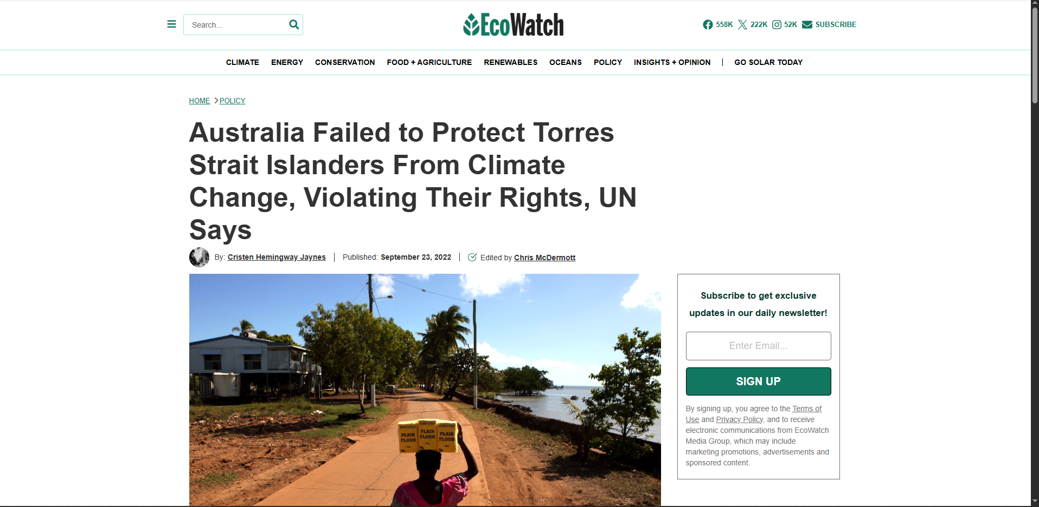

Engineers Without Borders Australia. (2025). *Saibai Island, TSIRC*. [https://ewbchallenge.org/challenge/saibai-island-tsirc/](https://ewbchallenge.org/challenge/saibai-island-tsirc/?utm_source=chatgpt.com)

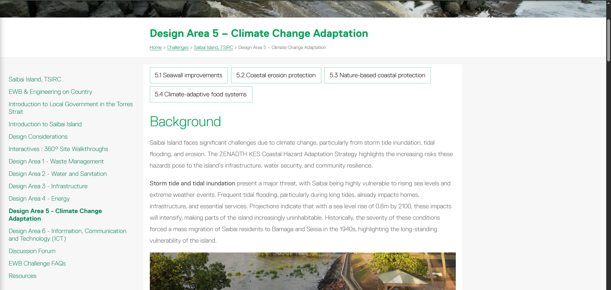

Park, A., McDonald, A., & Ky, J. (2021, April 18). *For these Torres Strait Islanders, climate change is already here — and they're urging the government to do more*. ABC News.

[https://www.abc.net.au/news/2021-04-19/torres-strait-islanders-climate-change-impacts-uninhabitable/100069596](https://www.abc.net.au/news/2021-04-19/torres-strait-islanders-climate-change-impacts-uninhabitable/100069596?utm_source=chatgpt.com)

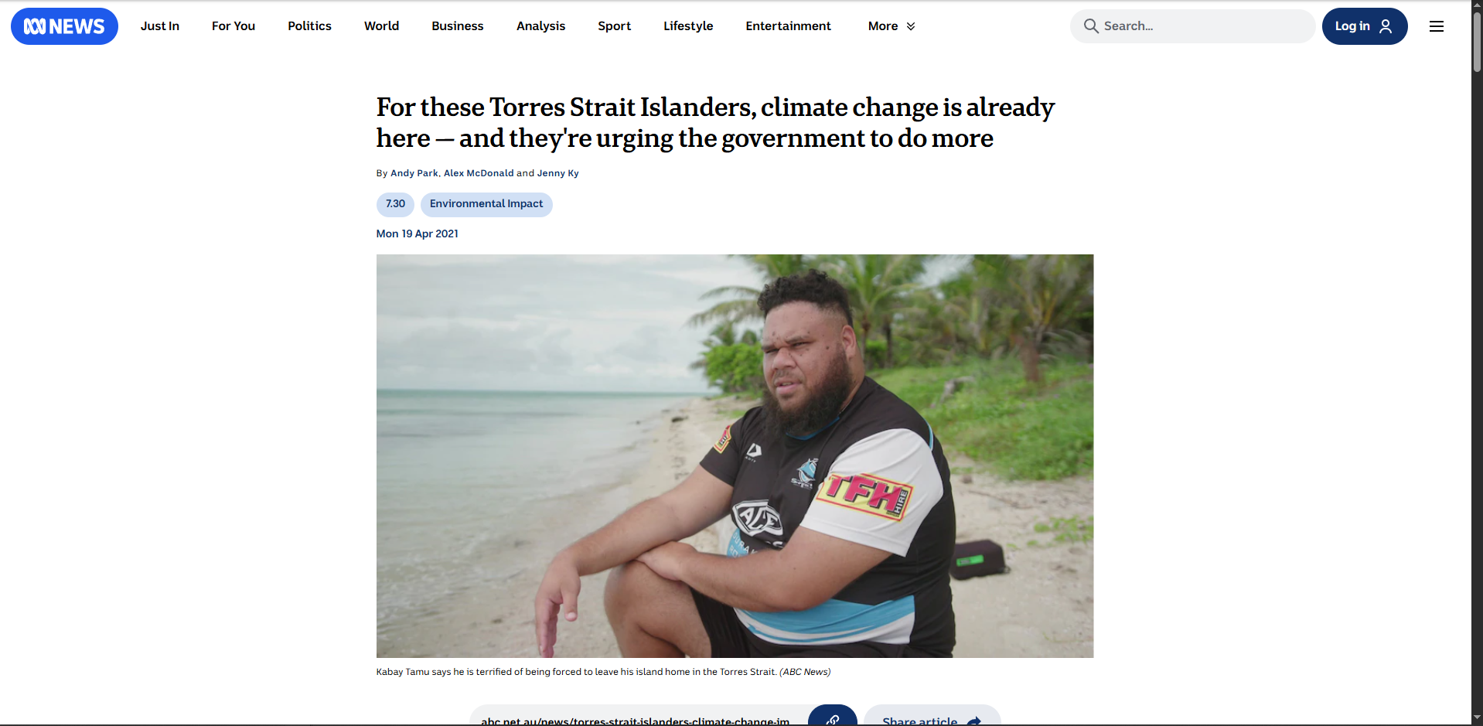

Queensland Government. (n.d.). *Saibai*.

<https://www.qld.gov.au/firstnations/cultural-awareness-heritage-arts/community-histories/community-histories-s-t/community-histories-saibai>

